8. Library Management Assistant Using Function Calling
1. Introduction
Generative AI is capable of understanding natural language and performing tasks by calling predefined functions. Function calling enables an AI model to interact with external systems instead of only generating text responses. This makes AI assistants more accurate, reliable, and useful for real-world applications.
A Library Management Assistant is an AI-powered application that helps students and library staff search for books, verify book availability, and retrieve information quickly. Instead of manually searching through library records, users can simply ask questions in natural language such as "Search for Python Programming" or "Is Data Structures available?". The AI interprets the request, calls the appropriate function, and returns the required information.
In this assessment, two functions are designed:
- search_book() to search for books in the library database.
- check_availability() to verify whether a book is available or already issued.
The AI assistant identifies the user's intent, invokes the correct function, and provides the response.
2. Objectives
The objectives of this assessment are:
- To understand the concept of function calling in Generative AI.
- To design functions for searching books in a library database.
- To implement a function that checks book availability.
- To simulate AI decision-making using user queries.
- To demonstrate how Generative AI invokes different functions based on user intent.
- To improve automation in library management systems.
- To reduce manual effort in searching library resources.
- To provide fast and accurate responses to users.
3. Problem Statement
A college library contains thousands of books, making manual searching time-consuming. Students often need to know whether a particular book exists in the library and whether it is currently available.
Design an AI-powered Library Management Assistant using function calling. The assistant should:
- Search for a book using the search_book() function.
- Check whether the requested book is available using the check_availability() function.
- Demonstrate function calling with at least three different user queries.
4. Proposed Solution
The proposed solution consists of:
- A library database stored as a Python dictionary.
- A search_book() function to search books.
- A check_availability() function to check book status.
- A simple AI assistant that understands user queries and calls the required function automatically.

5. Function Description
Function 1: search_book()
Purpose:
Searches the library database for a requested book.
Input:
- Book Name
Output:
- Book title
- Author name
- Book found / not found
Function 2: check_availability()
Purpose:
Checks whether the requested book is available.
Input:
- Book Name
Output:
- Available
- Not Available
- Book Not Found

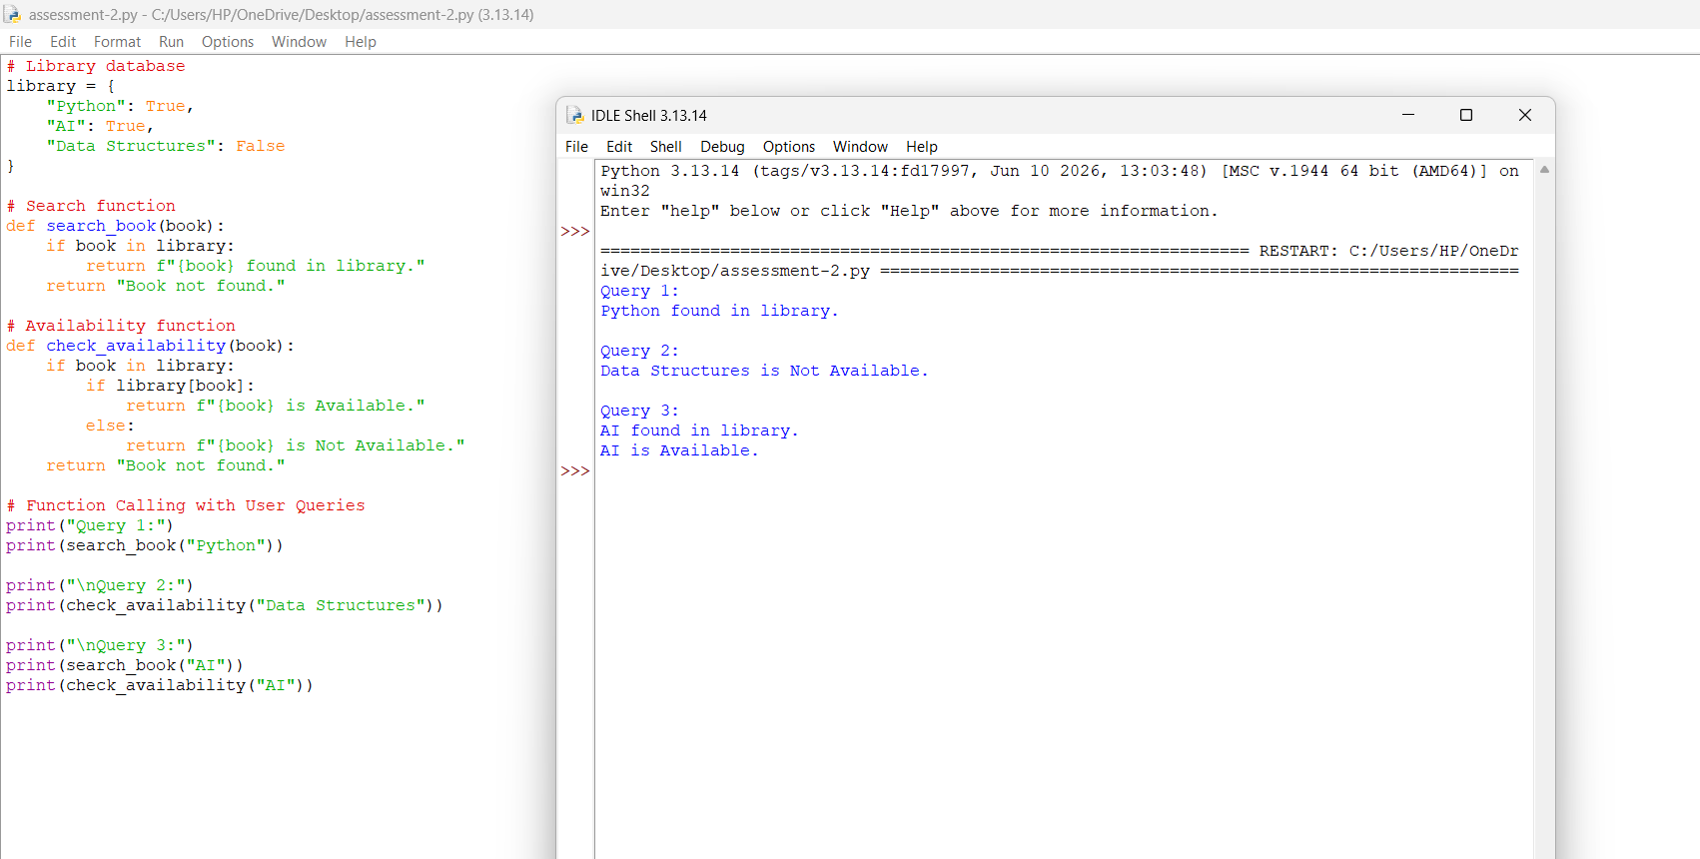

7. Function Calling Demonstration
Query 1
User:
Search for Python Programming
Decision:
Calls search_book("Python Programming")
Response:
Title : Python Programming
Author : John Smith
Query 2
User:
Is Data Structures available?
Decision:
Calls check_availability("Data Structures")
Response:
Not Available
Query 3
User:
Find Artificial Intelligence
Decision:
Calls search_book("Artificial Intelligence")
Response:
Title : Artificial Intelligence
Author : David Brown

8. Expected Output
Query 1
{'Title': 'Python Programming',
'Author': 'John Smith'}
Query 2
Not Available
Query 3
{'Title': 'Artificial Intelligence',
'Author': 'David Brown'}
9. Advantages
- Reduces manual searching time.
- Provides quick responses.
- Improves library efficiency.
- Easy to integrate with AI systems.
- Demonstrates real-world Generative AI function calling.
- Can be expanded to support book borrowing and returning.
10. Applications
- College libraries
- School libraries
- University digital libraries
- Public libraries
- E-learning platforms
- Online book catalog systems
11. Conclusion
This assessment demonstrates the use of function calling in Generative AI through a Library Management Assistant. The AI understands the user's natural language query, identifies the required action, invokes either the search_book() or check_availability() function, and returns the appropriate response. This approach makes AI systems more interactive, efficient, and suitable for real-world applications such as library automation.

